Serial Number: IF4SM1ZN0NAG

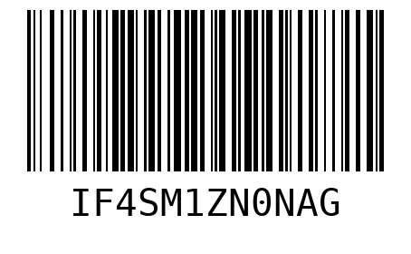

Serial Number: KY7ES8D9PZ42

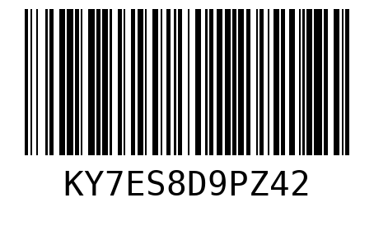

Serial Number: XZBWSVB6SAD7

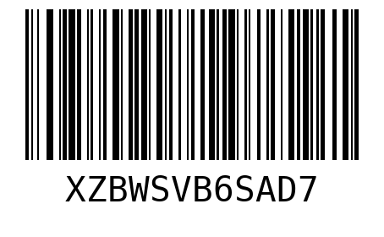

Serial Number: 5EPIWD5PMID6

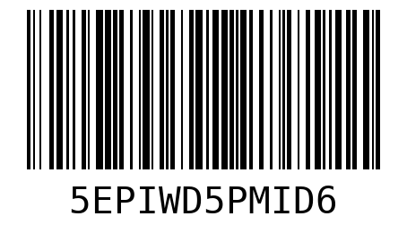

Serial Number: WNS033ISLYUO

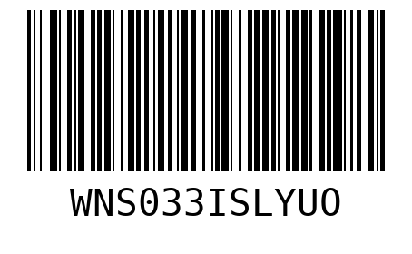

Serial Number: ZUSV7O05AYX4

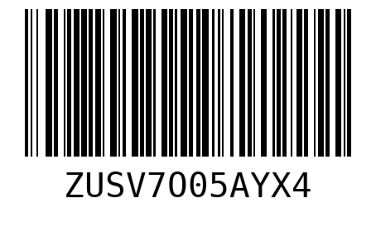

Serial Number: 6BAEODZCSP1Y

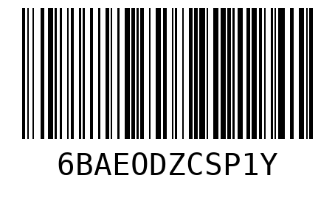

Serial Number: NHI5VXNVP2WY

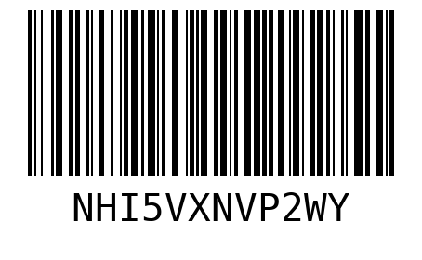

Serial Number: D577O3CHOJD1

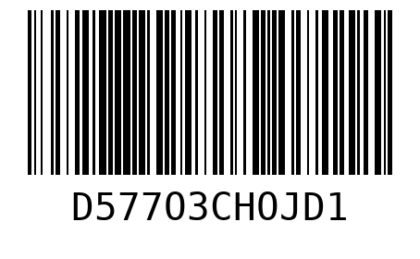

Serial Number: PQOIQLF14X79

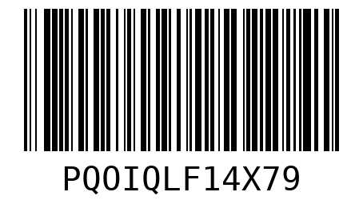

Serial Number: 5Y61AFGPR4W0

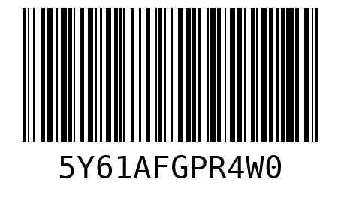

Serial Number: 8Y85EWVMJ22K

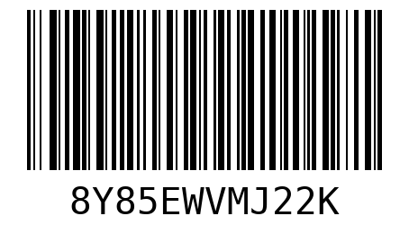

Serial Number: 81YE7UJIL0D9

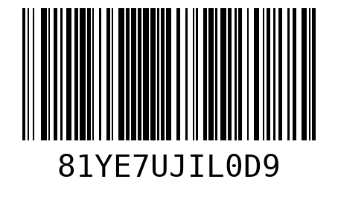

Serial Number: UOOMWSU0BOXA

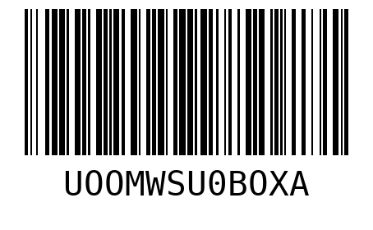

Serial Number: W24ZQN5WJJX3

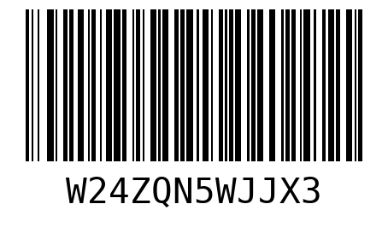

Serial Number: R8AX3OJHHP60

